**MCIS 6333_002 – Data Visualization Programming**

**Fall 2023 Dr. Esther Ledelle Mead, Professor**

**Assignment 3 (A3)** Module 3 12 points

**Instructions**: Work as a team to fill in your team and team member information. Then continue to work as a team to enter responses for each of the three sections: 1) DVs programmed in Python, 2) DVs programmed in R, and 3) Data insights. Do not change the file name of this template except for adding your Team Number and name at the end of "A3-MCIS6333_002" (for example, "A3-MCIS6333_002-Team_1-Bad-To-The-Bone.docx"). Do not remove any content from this template. **Before submission, be sure that all required components are visible on the final version of your file by expanding their edges as needed and by inserting extra space as needed. Be careful not to move around the objects on this document in a way that messes up the flow. As you add content, the items will be pushed down, which is fine, but be sure to not let any DVs get split up or caught in between two pages. Create as many additional pages on this file as necessary. Turning in work created by students/teams from a past semester will result in a score of zero (0) and an official Academic Dishonesty and Integrity Violation report for each team member to the SAU Authorities.**

**Team #: _1___ Team Name: __Datavana_____  
   
 Contributed effort to this A3? *(Y or N)***

**Team Members (*full names are required*): *Answer required for each team member):*  
1. Revanth Kumar Madasu____________________ __Yes  
2. Anusha Pakkiru____________________ __Yes  
3. ________________________________________ _____  
*(Remove any unused lines from above.)***

**1) Data visualizations (DVs) programmed in Python that show the M3 theme of Data Composition based on your team’s Use Case M1, M2, and M3 dataset files**:

Insert your DVs below this line.

**Ethnicities:**

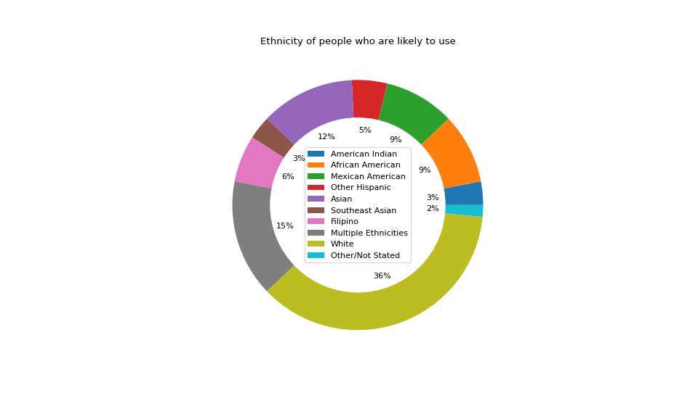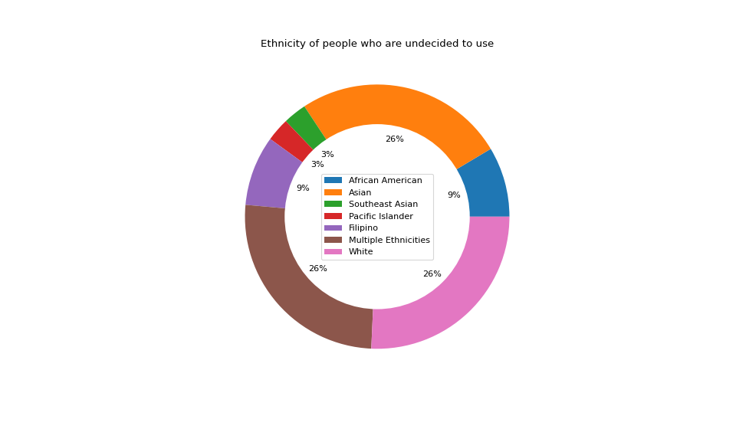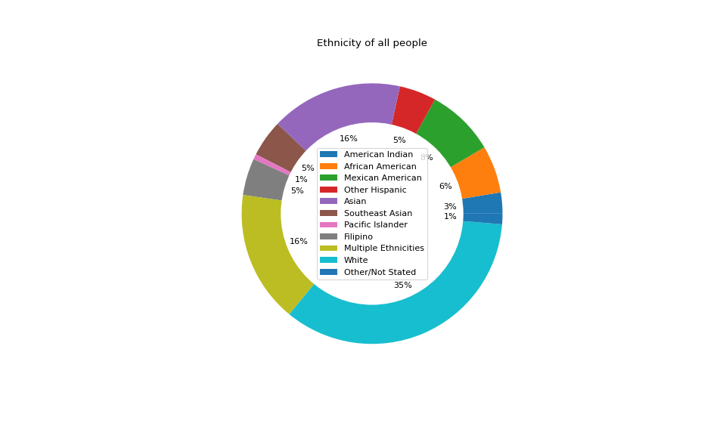

**People likelihood to use Elite Party Services:**

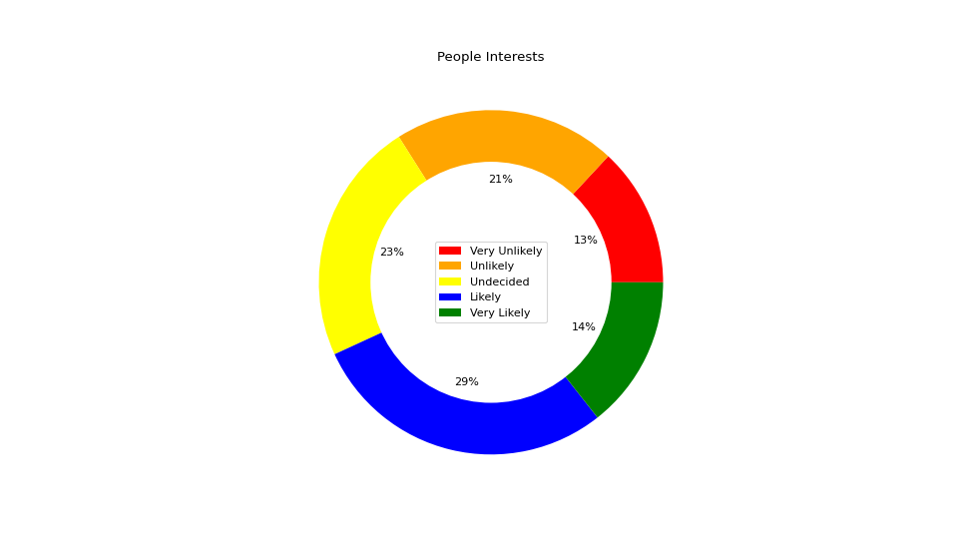

**In which seasons mostly used ?:**

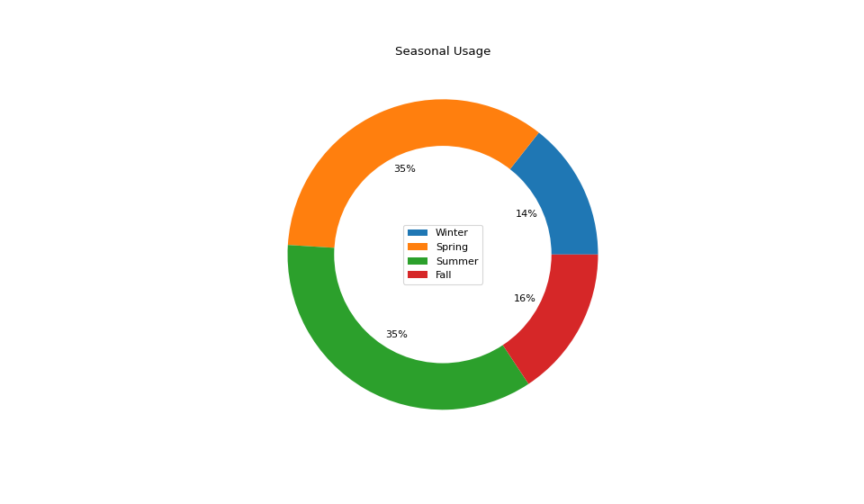

**Internet Usage of different people by likelihood:**

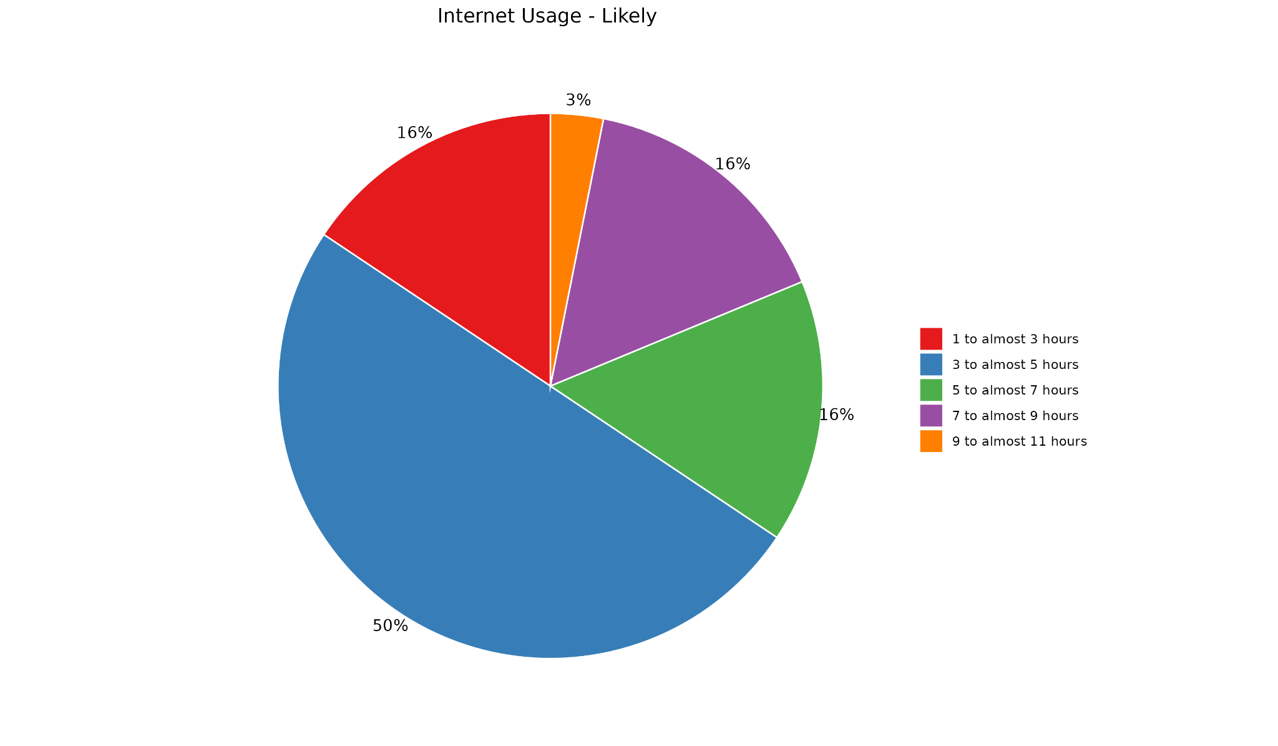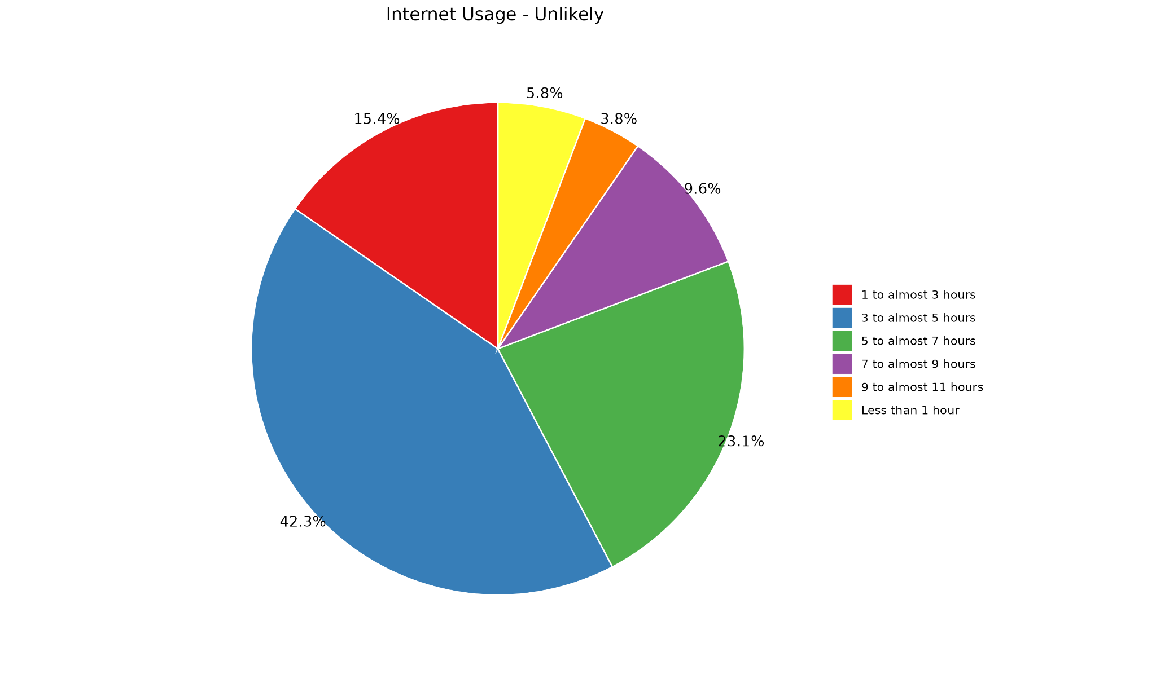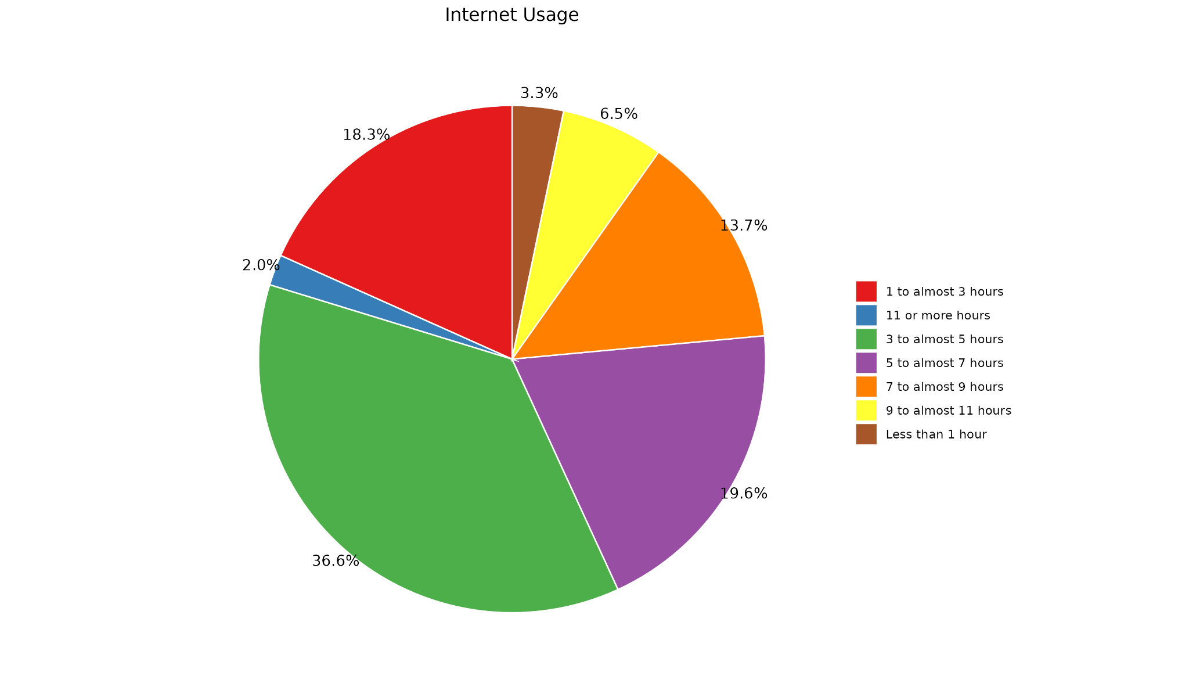

**2) Data visualizations (DVs) programmed in R that show the M3 theme of Data Composition based on your team’s Use Case M1, M2, and M3 dataset files**:

Insert your DVs below this line.

**Ethnicities:**

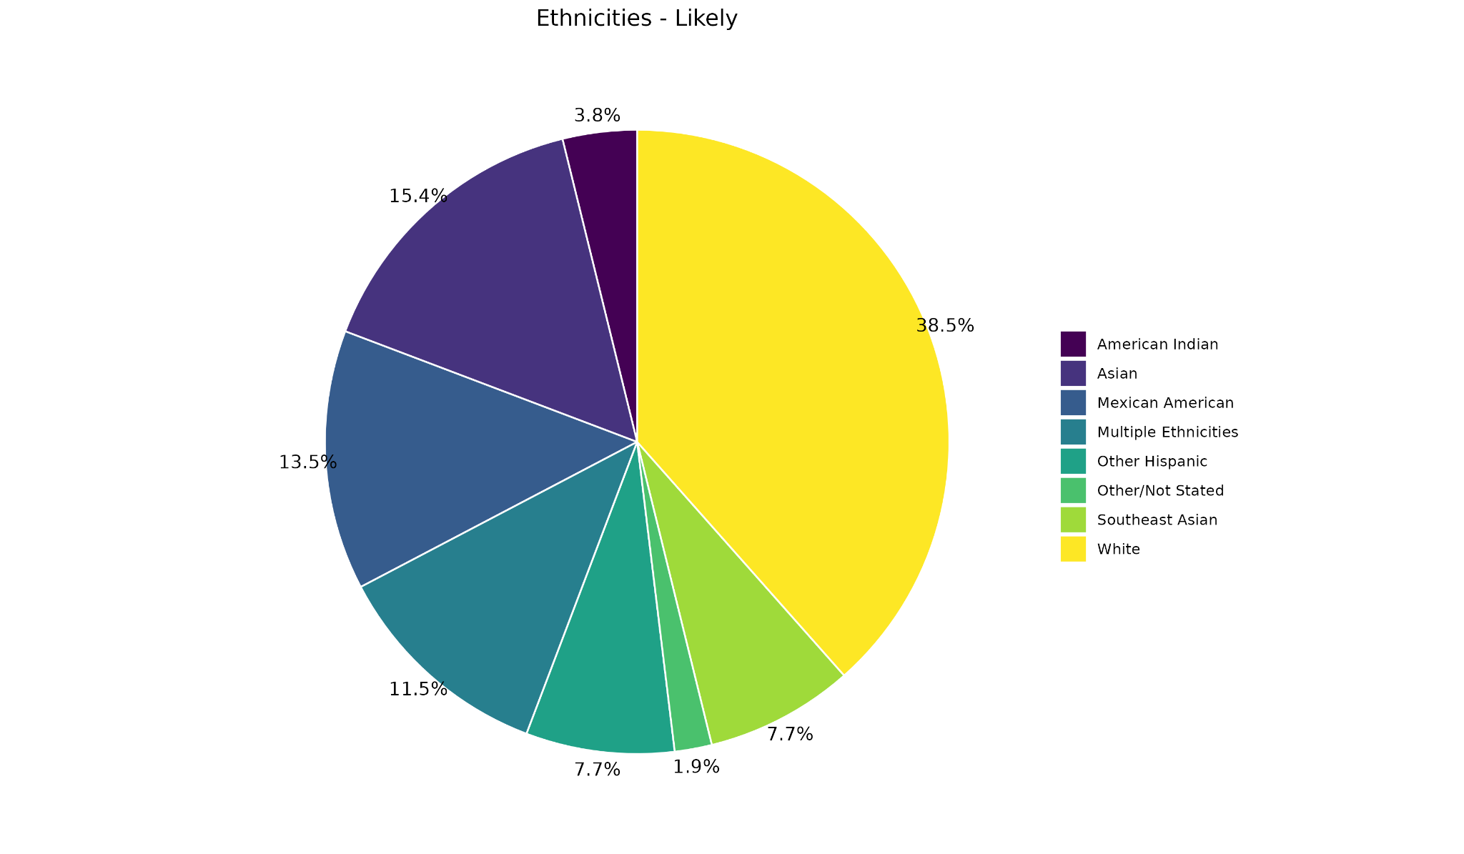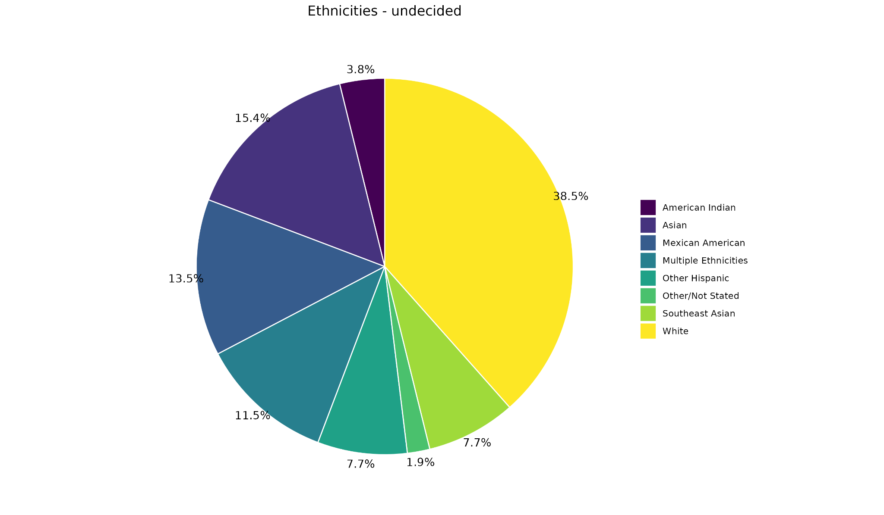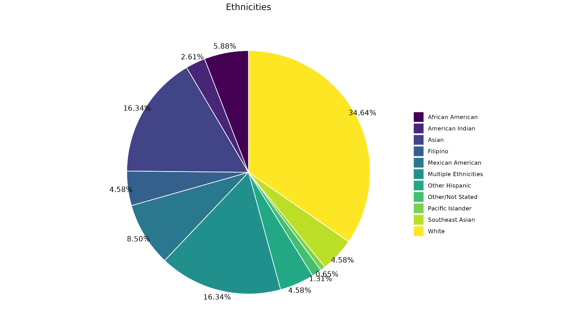

**People likelihood to use Elite Party Services:**

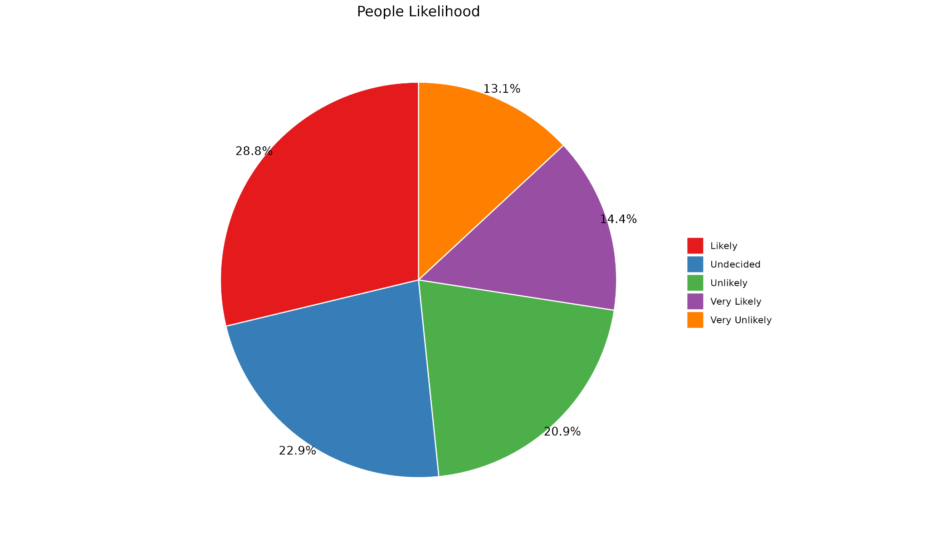

**Seasons mostly used :** 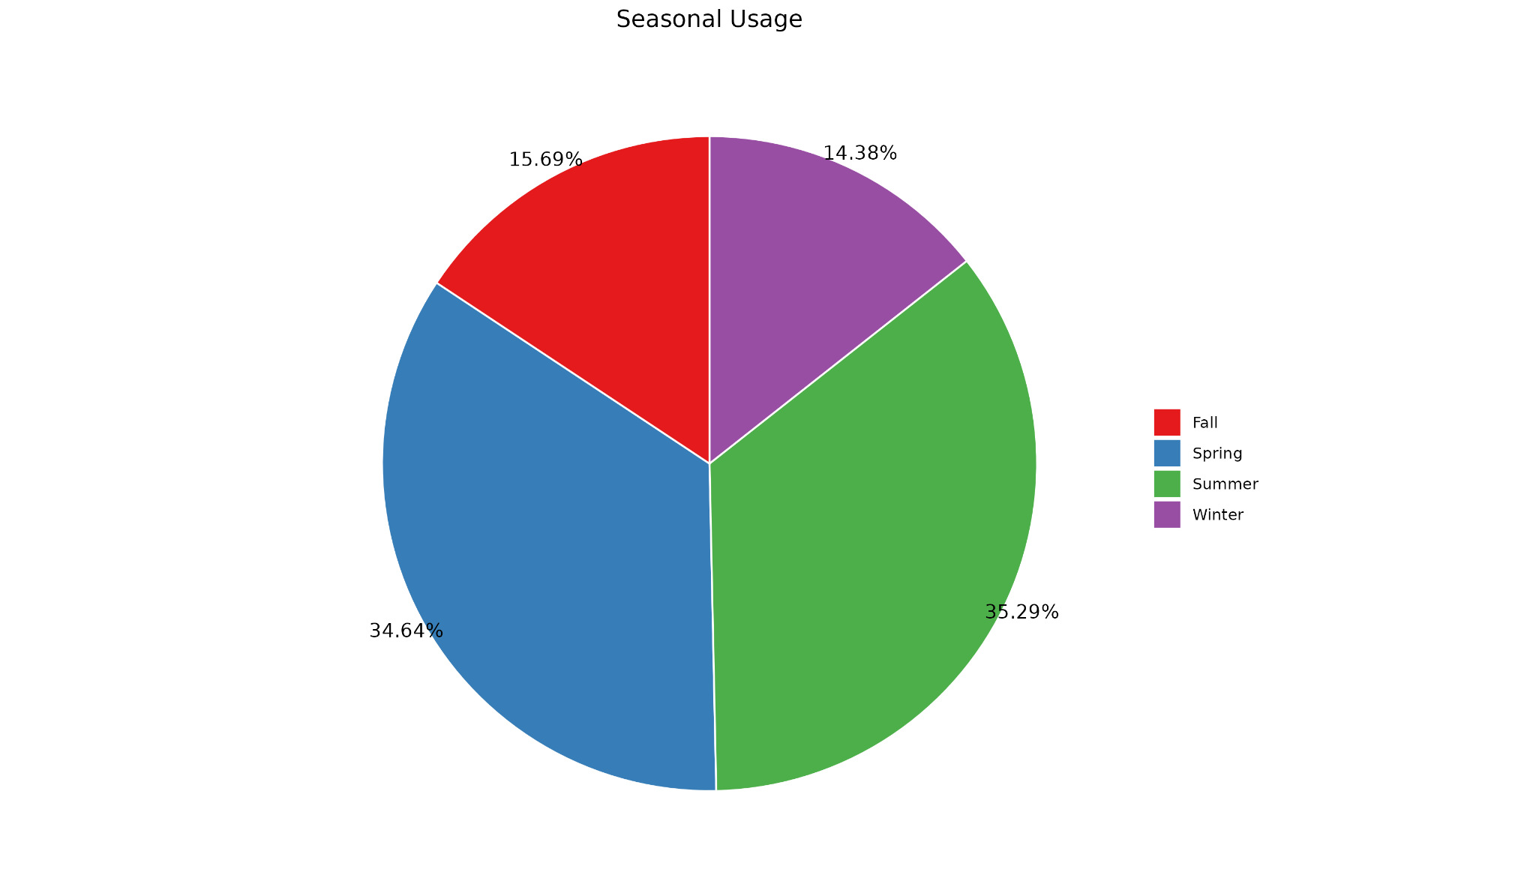

**Internet Usage of different people by likelihood: **

**3) Data insights:**

Below this text instruction line, insert at least three properly structured and arranged sentences (grammar, spelling, sentence casing, use of spacing, symbols and punctuation) to compose some data insights that can be logically deduced from the DVs that you provided above and that say something about the data with regard to the M3 theme of Data Composition. If you write more than three sentences, be sure to use appropriate paragraphing structure for technical writing[1].

i) From **People likelihood to use Elite Party Services,** you can see many people are likely to use Elite party services which is good.

The next majority is people who are undecided with 23%.

We can target people who are undecided by providing extra benefits which require less effort but enough push to make them likely to use.

ii) From **Ethnicities,** We can observe amount undecided people, white is 26%, asian is 26%, multiple ethnicities is 26 %

Among likely to use white is 36% and multiple ethnicities is 15% but asian is little low - 12%.

Asian ethnicity is second largest (16% from our responses) and we have 26% undecided which is high and only 12% who are likely to use.

Which means steps should be taken to reach out to asian ethnicity to increase likelihood as more number of people are undecided.

The first largest ethnicity is white which is doing good in likelihood of usage.

iii) From **Seasons mostly used,** you can see many people are likely to use Elite party services in spring and summer which makes sense as people are usually socially active in these periods.

iv) From **Internet Usage of different people by likelihood,** Comparing all the three internet usages, you can notice people in unlikely category use internet slightly more (79% people use atleast more than 3 hours of internet) than likely category (74% people use atleast 3 hours).

This makes sense as it can be understood that people who spend more time on devices are less socially active.

So to increase the customers, ads can be targetted on the internet to change the behaviour of unlikely users

**MCIS 6333_002 – Data Visualization Programming**

**Fall 2023 Dr. Esther Ledelle Mead, Professor**

1. <https://developers.google.com/tech-writing/one/paragraphs>